Times Table
Policy

Responsible Person: Jack Thompson
February 2024 to February 2025

VISION
At Park Primary, we want to nurture a love and enjoyment of mathematics in all of our children so that they are keen to explore different concepts and discover the wonder of mathematics and linking this to their every-day world.

AIMS
- To provide a common framework for testing so that a consistent approach is used by all staff throughout the school in order to ensure that all children progress.
- To ensure all children improve their fluency in mental arithmetic.
- To ensure all children are fluent in recalling their times tables facts at speed.

TESTING
The quick recall of multiplication facts (times tables) is essential for all children. The ability to recall these facts quickly enables children to answer related questions with ease.
All KS2 year groups will complete the tests and Year 2 will begin their tests in the Summer term.
A times table test will be carried out once a week during mental maths time.
TT RockStars will be used to facilitate the test The test questions will be selected by the class teacher dependent on each child’s level and target.
The tests will be progressive; children only moving onto the next set once they have achieved 25/25 on three consecutive occasions.

The test sets are as follows:
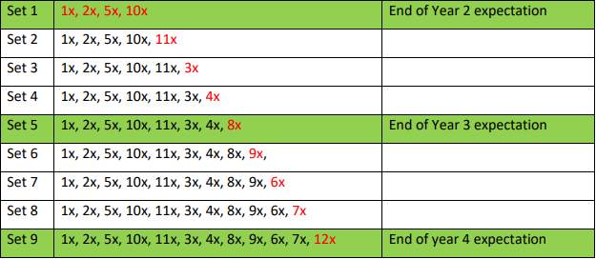
The children identified as regularly scoring below 20/25 will be part of a small intervention group to support their gaps. This will take place straight after the test with the class’s support. Class teachers are responsible for rewarding children when they move onto the next set. Children who achieve 25/25 on 3 consecutive occasions on the last set will be challenged to other facts.

See below:
- All multiplication and division to 12 x12
- Include multiples of 10,100 (30x60)
- Squares
- Cubed
- All multiplication and division to 12 x12 include 10 x100 (30x60) x 0.1 x 0.01 (0.3x0.6)
- Percentages
- Doubles halves decimals 100-2dp

YEAR 4 MULTIPLICATION CHECK
The Department for Education introduced a statutory multiplication check for all Year 4 pupils in June 2022. The purpose of the check is to determine whether children can fluently recall their times tables up to 12, which is essential for future success in mathematics. It will also help our school to identify who may need additional support. This test will be in school time, and will consist of 25 mixed questions. Pupils will have 6 seconds to answer each question.

TIMES TABLES TTROCKSTARS
TT RockStars is an educational learning platform which is specifically designed to support children in learning and becoming more fluent in their times tables. There are many different games and modes within this platform for children to practise in different ways. This is a useful tool for teachers as we are able to review children’s effort and performance, whilst also analysing data to identify any times tables which children are finding difficult.

SUPPORTING TIMES TABLES AT HOME
Whilst we do have a heavy emphasis on learning times tables at school, this is best supported when children also have opportunities to practise at home too. This practice can be verbal, using home resources, or of course using platforms like TTRockStars or Hit the Button.
It is really important to remember that counting in multiples of any number IS NOT the same as knowing times table facts.
Whilst there is an expectation for children to be able to count in multiples of all numbers there is also the expectation they can recall any multiplication fact at speed.

